**Part 1 - Create Component**

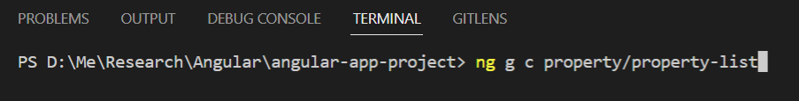

Go to root directory , and type **“ng g c property/property-list” / “ng generate component property/list”**

|  |
| --- |
| Notes :   1. g = generate 2. c = component 3. Property/ = it will make “property” folder, then within it, the component will be generated 4. property-list (using dash character is a convention of component naming) |

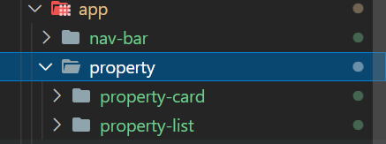

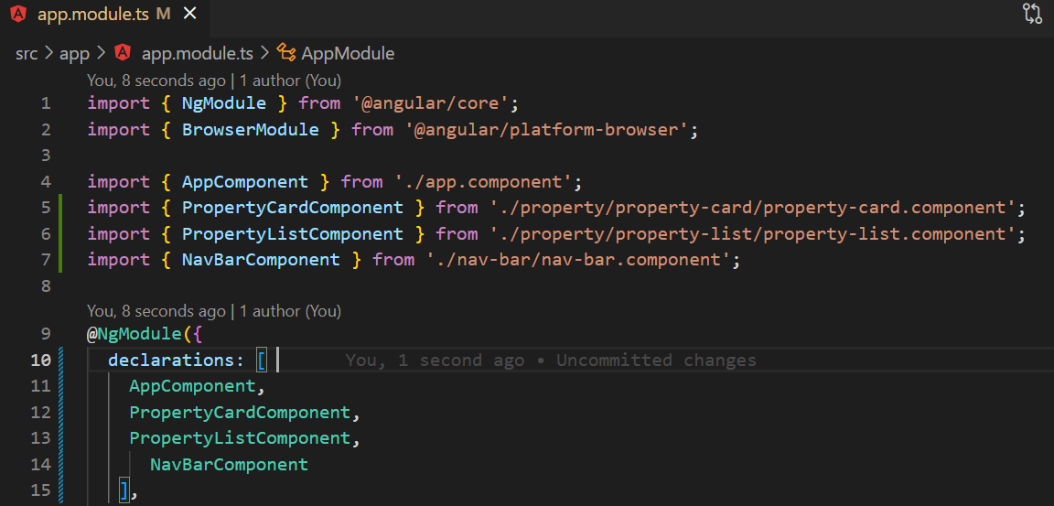

After that register your new components into app.module, in case your components haven’t registered

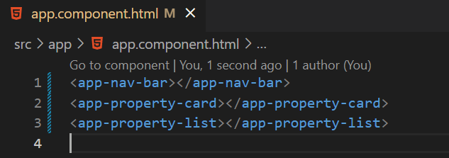

Call component selector from app.component.html and type “ng serve” to run the application

